
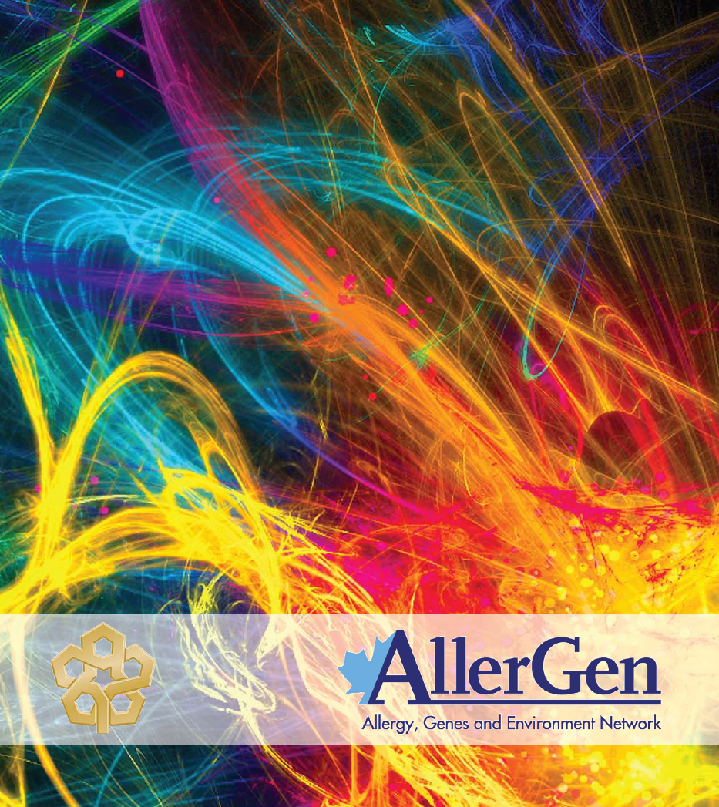


AllerGen KT Tool for Biomedical Researchers
(Excerpt in Word Format)

Innovation from cell to society
www.allergen-nce.ca

ACKNOWLEDGEMENTS:

AllerGen NCE Inc. acknowledges with appreciation Réjean Landry, CHSRF/CIHR Chair -
Knowledge Transfer and Innovation, Université Laval, Québec, for granting AllerGen permission to adapt his team’s knowledge planning tools for stroke researchers for use by allergic disease researchers and their partner organizations.

AllerGen hopes that you find this Word version of the AllerGen Knowledge Translation Planning Tools for Allergic Disease Researchers helpful. AllerGen envisions this document as organic; it will evolve with the benefit of your feedback. Future versions will reflect new understanding gained from your input.

If you have suggestions that will improve this tool, please contact:
Diana Royce, Managing Director and COO, AllerGen NCE Inc. Email: info@allergen-nce.ca
© AllerGen NCE Inc. 2009

AllerGen NCE Inc.
MDCL Room 3120, McMaster University, 1200 Main Street West, Hamilton, ON L8N 3Z5
Tel. (905) 525-9140 ext 26502 Fax. (905) 524-0611 www.allergen-nce.ca
A KNOWLEDGE TRANSLATION PLANNING TOOL FOR CLINICAL, HEALTH SERVICES & POPULATION/PUBLIC HEALTH RESEARCHERS

INTRODUCTION

Knowledge translation (KT) is the term used by the Canadian Institutes of Health Research (CIHR) to describe the dynamic and iterative processes that include synthesis, dissemination, exchange and ethically-sound application of knowledge to improve the health of Canadians, provide more effective health services and products and strengthen the health care system.

In general terms, KT is a process that aims to engage potential stakeholders in the research process and place research results into the hands of organizations and individuals who can apply them in practice. It is also about communicating and sharing research results in new ways that inspire people to think and/or act differently. While there are a variety of terms used in the literature to refer to this process (e.g., knowledge transfer, exchange, uptake and mobilization, utilization and diffusion), the KT process is achieved through transmission and exchange of information and also through extensive dialogue between the producers and users of research. KT involves careful consideration of the experiences and information needs of stakeholders to enhance the creation of new theory, improve the overall quality of research and facilitate the application of research to practice and policy.

In integrated KT, stakeholders or potential research knowledge users are engaged in the entire research process, working together to shape the research process and collaboratively determine research questions, decide on the methodology, participate in data collection and tools development, interpret findings and help disseminate research results. This approach, also known as collaborative research, action-oriented research and co-production of knowledge should produce research findings that are more relevant to and used by end-users.

It is important to develop an appropriate KT strategy as part of your initial research plan to maximize the value of research for those who can benefit from its results. Integrated KT is consistent with AllerGen’s networked, multisectoral and multidisciplinary approach to research wherein researchers and knowledge users work together to identify research questions, decide on methodology, and interpret and disseminate findings tailored to specific audiences.

This document, A Knowledge Translation Planning Tool for Clinical, Health Services & Public Health Researchers, provides a comprehensive overview of factors to consider in developing an integrated KT strategy. Effective KT is a continuous process which starts during the development of a research project. With this process in mind, the tools in this document are designed for use from the beginning of your research project throughout its duration to help create and implement a comprehensive KT strategy. Project team members should consider the items mentioned in this KT tool in developing a plan for achieving research project objectives.

The tools are based on the following six questions to help you and your research team to enhance the knowledge transfer potential of your research:

1. What are the most important aspects to consider when establishing a KT strategy?
2. What are the outputs of your research (e.g., findings, concepts, methodologies, tools)?
3. Who are the potential users of your research outputs?
4. What is the most effective way to make contact and interact with those users (e.g., how to
bring knowledge to the clinician)?
5. How can potential users be involved in meaningful ways throughout the research project?
6. What do users need to know about your research in order to understand it and assess its
value for potential uptake

HOW WAS THE KT TOOL DEVELOPED?

In 2005/06 researchers associated with the Chair on Knowledge Translation and Innovation at Laval University and the Atlantic Health Promotion Research Centre (AHPRC) at Dalhousie University dedicated themselves to identifying factors that contribute to an effective KT strategy. After these factors were identified, information from 98 innovative tools on KT was synthesized to isolate the critical elements applicable to stroke research. With permission and support from the research authors, in 2009, AllerGen NCE Inc. assembled a team to tailor these same tools for use by Network-supported allergic and related immune disease researchers. The tailored document was then reviewed by AllerGen’s Research Management Committee (RMC) and Policy, Ethics and Law Society Committee (PELS) to ensure alignment with the context of allergic and related immune disease research, which includes allergy, asthma and anaphylaxis. Each question posed in the tools is supported either by credible internet sources or by factors identified in the literature to improve KT. Factors found to be associated with a successful KT strategy include:

• the effort users put into acquiring knowledge
• the degree to which research results fit the situation of the user
• the extent to which research results are disseminated among research users
• the linkage between researchers and users of research
• the quality and type of research
• publication assets
• sources of funding
• type of research (e.g., quantitative and qualitative methodologies)
• the context of the researcher and the research user.

HOW TO USE THE KT TOOLS

The integrated KT tool in this document was designed to help maximize the effectiveness of your KT strategy. There are no right or wrong answers. This tool has three main sections:

Knowledge Generation
Knowledge Transfer
Knowledge Uptake

Knowledge generation is defined as the development of research outputs or research syntheses; knowledge transfer is defined as the communication of research outputs to potential users; and knowledge uptake is defined as the uptake and use of research by potential users. Under these sections there are theme areas (e.g., assessing the outputs of your research) with checklists designed to help you identify areas for planning and improving your KT strategy. The checklist has the following format: first, the item to consider is identified; second, four categories have been provided to help you evaluate your progress in achieving the item (Done, To be done or NA [not applicable], By Whom, and When); and at the end of each section there is a space for additional notes related to the emerging “To-do” list.

Items to Consider | Done | To be done or NA | By Whom | When

If you have already addressed a particular item, check the “Done” box. If you can improve your efforts, make notes about next steps in the “To be done” box, identify who will lead the required actions and by when these actions should be completed. Because each research study or program is unique, some items will not apply to your research team. If an item does not apply to your team, write “NA” in the “To be done” box. After completing the tool, review each item on the checklist and summarize the items in a “To do” list. You can use this list to create a work plan for your KT strategy, which should include proposed actions, research team roles/responsibilities and an associated time-line.

REFERENCES

• Landry, R., Amara, N. and Lamari, M. (2001). “Utilization of social science research knowledge
in Canada.” Research Policy. Vol. 30: 333-349.

• Landry, R., Lamari, M. and Amara, N. (2003). “The extent and determinants of the utilization of
university research in government agencies.”
Public Administration Review. Vol. 63, Iss. 2: 192-206.

• Lyons, R. and Warner, G. (2005). Demystifying Knowledge Translation for Stroke Researchers:
A Primer on Theory and Praxis. Canadian Stroke Network: 22 pages.
Available at www.canadianstrokenetwork.ca.
Knowledge Generation

PART B: A KNOWLEDGE TRANSLATION PLANNING TOOL FOR CLINICAL, HEALTH SERVICES & POPULATION/PUBLIC HEALTH RESEARCHERS
SECTION 1 - KNOWLEDGE GENERATION
1.1 Including KT in the Early Stages of Your Research
This section will help you identify information you could gather from different stakeholders (potential users) potentially interested in your research outputs. This information should be considered at the beginning of the research project (i.e., before or during the preparation of your grant proposal).
In developing your research project you should consider: | Done | To be done or NA | By Whom | When
Using ideas and information obtained through collaboration with other researchers in public and private research institutions including hospitals, universities and government laboratories
Using ideas and information from generalists and specialists
Using ideas and information from individuals with allergy and asthma and their families, disease-based organizations and community groups
Using ideas and information from policy-makers involved in decision-making related to prevention, treatment and management of allergic disease
Using ideas and information from managers in health services organizations, physicians and other health professionals
Developing a strategy to ensure training for research trainees, new research professionals and other personnel
Identifying how the research outputs will benefit in the prevention, treatment and management of allergic disease

1.2 Assessing the Outputs from Your Research
This section will help you identify the outputs from your research project.
Consider project outputs: | Notes
List potential outputs generated by your research project (e.g., concepts, theoretical frameworks, methods, findings, technologies, syntheses, cures):
Describe the groups with which you will want to share your outputs, how to engage them in your research project and in what capacity:

Consider whether or not your project will add to the advancement of knowledge by: | Done | To be done or NA | By Whom | When
Validating or contradicting previous knowledge in the field of allergic disease prevention and treatment
Shedding light on issues related to allergic disease prevention, treatment and management
Providing solutions to specific problems related to allergic disease prevention, treatment and management

1.3 Building KT Capacity Among Your Research Team Members
This section helps you identify how each research team member can play a role in maximizing KT and the applicability of the research outputs.
To maximize the KT potential of your research outputs you should: | Done | To be done or NA | By Whom | When
Define team members’ roles, tasks and commitments that facilitate the application of research outputs to your disease prevention, treatment and management
Ensure that team members share a common vision about how the research outputs can be applied to your disease prevention and treatment
Identify one or more team members who will be in charge of establishing contacts with individuals with allergy and asthma and their families, disease-based organizations and other relevant agencies
Identify people who will be in charge of forming connections with individuals in business, health care decision-making, government and other relevant sectors
Establish an advisory group to consider the diverse viewpoints of each one of the project’s stakeholders as appropriate (e.g., health services, government agencies, non-government organizations, health care consumers, funding agencies)

Notes:

1.4 Evaluating Project Fit with Your Funding Agency’s Research
Objectives
When conducting your research, you should consider the importance of: | Done | To be done or NA | By Whom | When
Publishing your findings in relevant scientific journals
Publishing your findings in open access journals or online repositories
Publishing your discoveries in professional publications (e.g., Medical Post)
Forming collaborations with research teams in other disciplines relevant to the goals of the funding agency
Forming collaborations with researchers outside the region to enhance the quality and use of your research outputs
Improving or developing practices in allergic disease prevention, treatment and management
Contributing to policy decisions in allergic disease prevention, treatment and management
This section helps you identify how each research team member can play a role in maximizing KT and the applicability of the research outputs.
Notes:

1.5 Assessing Partnerships
This section helps you analyze what partnerships and contractual arrangements are important to ensure that your research outputs are used.

In order to maximize the application of your research outputs you should: | Done | To be done or NA | By Whom | When
Identify the types of resources (e.g., human, financial) and partnerships needed to carry out the project
Assess partner resources (human, material and financial) such as scientific expertise, communication or distribution channels that might be leveraged for mutual benefit in the research process and dissemination of results
Assess whether partnerships or collaborations can be developed with stakeholders and health-services organizations for the improvement of allergic disease care and prevention and the integration of research results into policy or practice
Forming collaborations with researchers outside the region to enhance the quality and use of your research outputs
Consider a partnership agreement outlining the roles and responsibilities of those involved in applying your research

SECTION 2 - KNOWLEDGE TRANSFER
2.1 Sharing Research Outputs
This section highlights activities that could maximize potential use of your outputs.
To effectively disseminate your research output you should: | Done | To be done or NA | By Whom | When
Share results with your funding agency
Share outputs with other researchers
Share outputs with students
Share outputs with specialists in business, venture capital and intellectual property
Share research results with individuals with allergy and asthma and their families and with disease-based patient and research funding organizations
Share outputs with all project stakeholders, such as the general public using the popular media
Share outputs with health care decision-makers and government policy-makers
Share outputs with stakeholders and organizations outside the scholarly community
Facilitate the exchange of expertise between members of your team and organizations outside the scholarly community (e.g., staff exchange, equipment transfer)
Work as a consultant or advisor for private firms, government agencies or other organizations

Consider different dissemination formats for your research outputs: | Done | To be done or NA | By Whom | When
Articles in scientific or professional journals
Bulletins and newsletters
Briefing notes
Care pathways
Case reports
Clinical practice guidelines
Health technology assessment reviews
Mainstream media e.g., newspapers, magazines
Patient and/or professional educational tools
Presentations and seminars
Publications that focus on evidence-based health care
Research syntheses
Systematic reviews (including meta-analysis)
Technical reports
Websites and listserves
Other format identified by research team members and research partners

Notes:

2.2 Assessing Users’ Skills
This section will help you to assess if your potential users are able to understand your research outputs, so you can translate your outputs into a format that they will understand (e.g., Are they familiar with statistics?)
In order to assess research users’ skills you should: | Done | To be done or NA | By Whom | When
Identify the users’ capacity to interpret technical aspects of research reports (e.g., statistics)
Determine whether potential users will have the skills, attitudes and awareness needed to benefit from research outputs
Determine the potential users’ regular vocabulary and take it into consideration when presenting your research outputs

2.3 Keeping in Touch with Users
This section will help you develop a strategy for effective communication between your research team and the potential users of your research outputs throughout the project.

To keep in touch with users you should: | Done | To be done or NA | By Whom | When
Develop a plan to build and maintain direct relationships with intended users throughout the project (this may include: conferences, meetings, informal contacts, electronic mail, regular mail, phone and other means)
Have periodic briefings and produce progress reports during the course of the study to generate interest in the research outputs
Have person-to-person contact with potential users to ensure that the research outputs are clearly related to users’ needs
Develop clear-language tools for users based on their needs
Identify leaders inside user organizations who can initiate change at every level of the organization and if possible, actively involve these people in the project

2.4 Developing a Dissemination Strategy
This section highlights important points for you to consider when developing a dissemination strategy. These items should be considered early in the project, although the final strategy may not be finalized until the outputs are known.

In developing an explicit dissemination strategy you should: | Done | To be done or NA | By Whom | When
Identify types of media and others who can best deliver research results to potential users (e.g., opinion leaders, health charities, television reporters, newspaper columnists, websites, radio, etc.)
Promote the access and availability of research outputs by developing products for the target audience such as briefing notes, brochures and websites
Verify that the release of research outputs takes into account where and how the user will apply your research outputs
Notes:

2.5 Connecting Research Outputs with Potential Users of the
Research

This section helps you tailor your research outputs to users’ abilities.

In adapting research results for dissemination you should: | Done | To be done  or NA | By Whom | When
Customize research results to targeted user groups (e.g., journalists, general public, other researchers, clinicians, decision-makers)
Summarize research outputs in lay language (e.g., an executive summary, relatively brief text and appendices documenting detailed methods, data and analysis)
Emphasize key messages and recommendations so that users know how to take concrete action
Include “real world” examples: use storytelling or conduct demonstrations on how to use the research outcomes (bring the findings to life!)
Develop reports and products appealing to specific target audiences (e.g., use illustrations, color, humour and packaging as appropriate)
Ask for feedback from potential users before providing the final reports to the funder
Provide technical assistance to make it easier to understand the implications of using the research outputs (e.g., information help-lines)

SECTION 3 - KNOWLEDGE UPTAKE
3.1 Assessing Current Practices in the Field of Allergic Disease Prevention and Treatment
This section focuses on the uptake of research and how it can contribute to improving current practices in the field of allergic disease prevention and treatment.

To validate whether or not your research outputs can improve allergic disease prevention and treatment you should: | Done | To be done  or NA | By Whom | When
Assess the feasibility of implementing improved practices in allergic disease prevention, treatment and management
Assess the benefits of the proposed practices in comparison with current practices
Make plans to facilitate the uptake of research outputs
Suggest specifically how proposed changes in practice will result in better outcomes for the improvement of allergic disease care and prevention

3.2 Assessing Management and Policy-Decision Improvements
This section highlights how your research outputs can contribute to management and policy decisions.
In order to see the potential applicability of your research outputs to management and policy decisions you should: | Done | To be done  or NA | By Whom | When
Assess if your research outputs shed light on issues related to management and policy decisions
Compare the current situation to a situation where your research outputs were implemented in the past
Consider whether or not your research outputs validate and support previous management and policy decisions
If appropriate, work with key decision/policy-makers in allergic disease-based organizations, government and community groups
3.3 Assessing Your KT Strategy

This section will help you assess the effectiveness of your KT strategy. In other words, what difference did your research have on allergic disease prevention and treatment?

To assess your KT strategy, verify whether the users: | Done | To be done or NA | By Whom | When
Received your research reports and/or results
Read and understood your research outputs
Cited your research outputs
Attempted to implement outputs from your research
Used your results to update their methodologies or practices
Used your results to influence choices and decisions
Used your results to make specific changes in their organization or policies

Notes:

